1. Run jhipster in battlements
2. **Dependency merge;**

We need to add dependencies to package.json from ngx-admin/package.json that is not exists. Also you need to check version of dependency that is already exists. You can pick ngx-admin version if it is upper.

{  
 "name": "battlements",  
 "version": "0.0.0",  
 "description": "Description for battlements",  
 "private": **true**,  
 "license": "UNLICENSED",  
 "cacheDirectories": [  
 "node_modules"  
 ],  
 "dependencies": {  
 "@agm/core": "1.0.0-beta.2",  
 "@angular/animations": "~5.2.4",  
 "@angular/common": "5.2.4",  
 "@angular/compiler": "5.2.4",  
 "@angular/core": "5.2.4",  
 "@angular/forms": "5.2.4",  
 "@angular/platform-browser": "5.2.4",  
 "@angular/platform-browser-dynamic": "5.2.4",  
 "@angular/router": "5.2.4",  
 "@asymmetrik/ngx-leaflet": "3.0.2",  
 "@nebular/auth": "2.0.0-rc.5",  
 "@nebular/theme": "2.0.0-rc.5",  
 "@ng-bootstrap/ng-bootstrap": "1.0.0-beta.9",  
 "@swimlane/ngx-charts": "7.0.1",  
 "angular2-chartjs": "0.4.1",  
 "angular2-toaster": "4.0.1",  
 "bootstrap": "4.0.0",  
 "chart.js": "2.7.1",  
 "ckeditor": "4.7.3",  
 "classlist.js": "1.1.20150312",  
 "core-js": "2.5.3",  
 "font-awesome": "4.7.0",  
 "intl": "1.2.5",  
 "ionicons": "2.0.1",  
 "leaflet": "1.2.0",  
 "nebular-icons": "1.0.6",  
 "ng2-ckeditor": "1.1.13",  
 "ng2-smart-table": "1.2.2",  
 "ng2-tree": "2.0.0-rc.4",  
 "ngx-echarts": "2.0.0",  
 "normalize.css": "6.0.0",  
 "pace-js": "1.0.2",  
 "roboto-fontface": "0.8.0",  
 "jquery": "3.2.1",  
 "ng-jhipster": "0.4.0",  
 "ngx-cookie": "2.0.1",  
 "ngx-infinite-scroll": "0.5.1",  
 "ngx-webstorage": "2.0.1",  
 "reflect-metadata": "0.1.10",  
 "rxjs": "5.5.6",  
 "swagger-ui": "2.2.10",  
 "tether": "1.4.0",  
 "tinymce": "4.5.7",  
 "typeface-exo": "0.0.22",  
 "web-animations-js": "2.2.5",  
 "zone.js": "0.8.19"  
 },  
 "devDependencies": {  
 "@angular/cli": "1.6.6",  
 "@angular/compiler-cli": "5.2.0",  
 "@angular/language-service": "~5.1.0",  
 "@compodoc/compodoc": "1.0.1",  
 "@ngtools/webpack": "1.8.5",  
 "@types/d3-color": "1.0.5",  
 "@types/jasmine": "2.5.53",  
 "@types/jasminewd2": "2.0.3",  
 "@types/leaflet": "1.2.3",  
 "@types/node": "8.0.18",  
 "angular2-template-loader": "0.6.2",  
 "awesome-typescript-loader": "3.2.2",  
 "browser-sync": "2.18.13",  
 "browser-sync-webpack-plugin": "1.2.0",  
 "codelyzer": "4.0.2",  
 "copy-webpack-plugin": "4.2.3",  
 "conventional-changelog-cli": "1.3.4",  
 "css-loader": "0.28.4",  
 "exports-loader": "0.6.4",  
 "extract-text-webpack-plugin": "3.0.2",  
 "file-loader": "1.1.5",  
 "generator-jhipster": "4.14.0",  
 "husky": "0.13.3",  
 "html-loader": "0.5.0",  
 "html-webpack-plugin": "2.30.1",  
 "jasmine-core": "2.7.0",  
 "jasmine-spec-reporter": "4.1.1",  
 "karma": "1.7.1",  
 "karma-chrome-launcher": "2.2.0",  
 "karma-cli": "1.0.1",  
 "karma-coverage-istanbul-reporter": "1.3.0",  
 "karma-coverage": "1.1.1",  
 "karma-intl-shim": "1.0.3",  
 "karma-jasmine": "1.1.0",  
 "karma-jasmine-html-reporter": "0.2.2",  
 "karma-junit-reporter": "1.2.0",  
 "karma-notify-reporter": "1.0.1",  
 "karma-phantomjs-launcher": "1.0.4",  
 "karma-remap-istanbul": "0.6.0",  
 "karma-sourcemap-loader": "0.3.7",  
 "karma-webpack": "2.0.4",  
 "merge-jsons-webpack-plugin": "1.0.11",  
 "npm-run-all": "4.0.2",  
 "protractor": "5.1.2",  
 "phantomjs-prebuilt": "2.1.16",  
 "proxy-middleware": "0.15.0",  
 "rimraf": "2.6.1",  
 "source-map": "0.6.1",  
 "sourcemap-istanbul-instrumenter-loader": "0.2.0",  
 "style-loader": "0.18.2",  
 "stylelint": "7.13.0",  
 "to-string-loader": "1.1.5",  
 "tslint-loader": "3.5.3",  
 "ts-node": "3.2.2",  
 "tslint": "5.7.0",  
 "tslint-language-service": "0.9.6",  
 "typescript": "2.6.2",  
 "xml2js": "0.4.17",  
 "uglifyjs-webpack-plugin": "1.1.5",  
 "webpack": "3.10.0",  
 "webpack-dev-server": "2.9.5",  
 "webpack-merge": "4.1.1",  
 "webpack-notifier": "1.5.1",  
 "webpack-visualizer-plugin": "0.1.11",  
 "web-app-manifest-loader": "0.1.1",  
 "workbox-webpack-plugin": "3.0.0-alpha.3",  
 "write-file-webpack-plugin": "4.1.0"  
 },  
 "engines": {  
 "node": ">=6.9.0"  
 },  
 "resolutions": {  
 "source-map": "0.6.1"  
 },  
 "scripts": {  
 "lint": "tslint --project tsconfig.json -e 'node_modules/**'",  
 "lint:fix": "yarn run lint -- --fix",  
 "ngc": "ngc -p tsconfig-aot.json",  
 "cleanup": "rimraf target/{aot,www}",  
 "clean-www": "rimraf target//www/app/{src,target/}",  
 "start": "yarn run webpack:dev",  
 "serve": "yarn run start",  
 "build": "yarn run webpack:prod",  
 "test": "yarn run lint && karma start src/test/javascript/karma.conf.js",  
 "test:watch": "yarn test -- --watch",  
 "webpack:dev": "yarn run webpack-dev-server -- --config webpack/webpack.dev.js --progress --inline --hot --profile --port=9060 --watch-content-base",  
 "webpack:build:main": "yarn run webpack -- --config webpack/webpack.dev.js --progress --profile",  
 "webpack:build": "yarn run cleanup && yarn run webpack:build:main",  
 "webpack:prod:main": "yarn run webpack -- --config webpack/webpack.prod.js --profile",  
 "webpack:prod": "yarn run cleanup && yarn run webpack:prod:main && yarn run clean-www",  
 "webpack:test": "yarn run test",  
 "webpack-dev-server": "node --max_old_space_size=4096 node_modules/webpack-dev-server/bin/webpack-dev-server.js",  
 "webpack": "node --max_old_space_size=4096 node_modules/webpack/bin/webpack.js",  
 "postinstall": "node node_modules/phantomjs-prebuilt/install.js"  
 }  
}

1. **Copy ngx-admin ui-component files;**

mkdir src/main/webapp/app/ngx-admin;

cp -R ../ngx-admin/src/app/* src/main/webapp/app/ngx-admin/

1. **bootstrapModule switched to ngx-admin app-module**

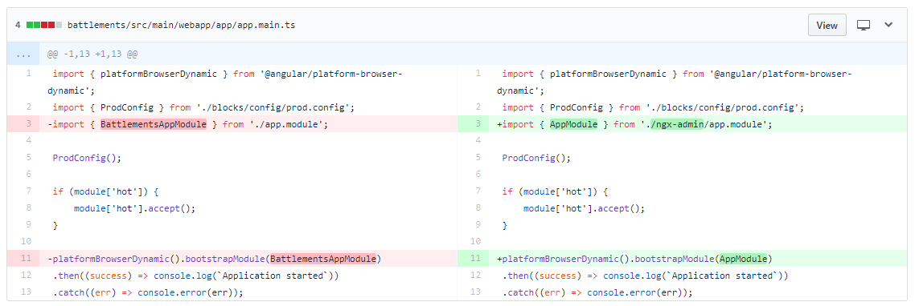

# Overwrite index.html from ngx-admin

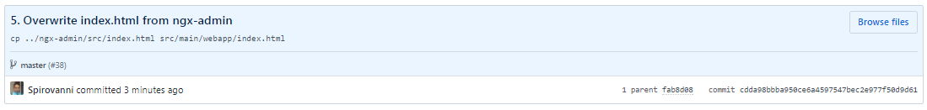

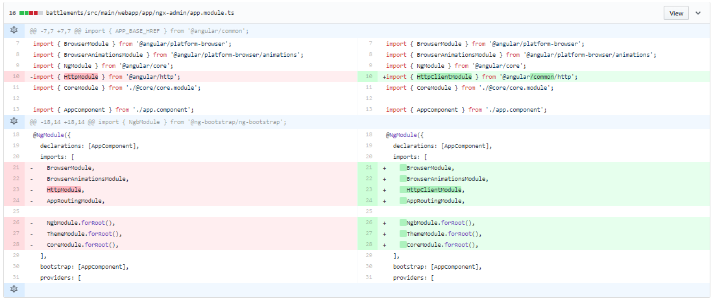

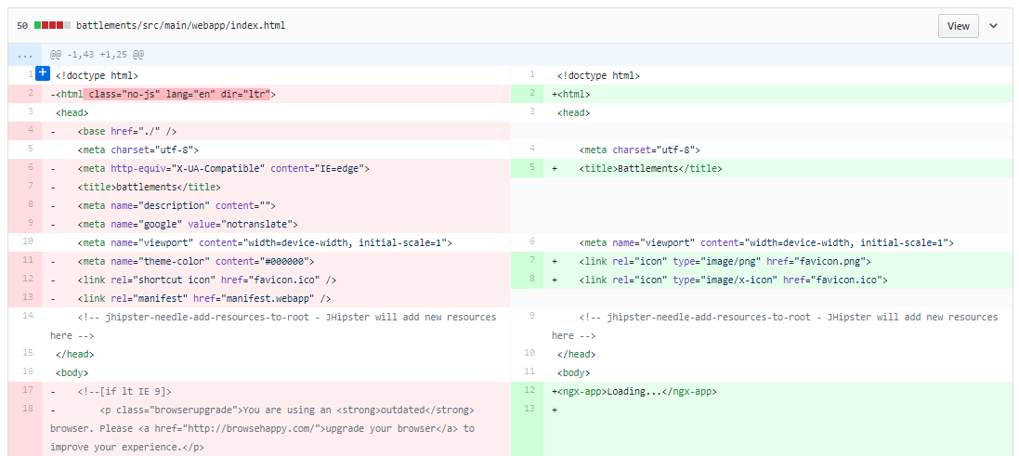

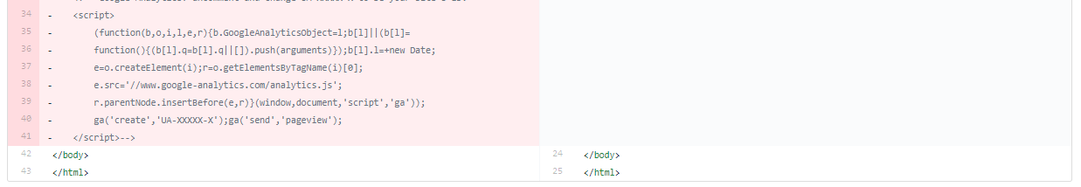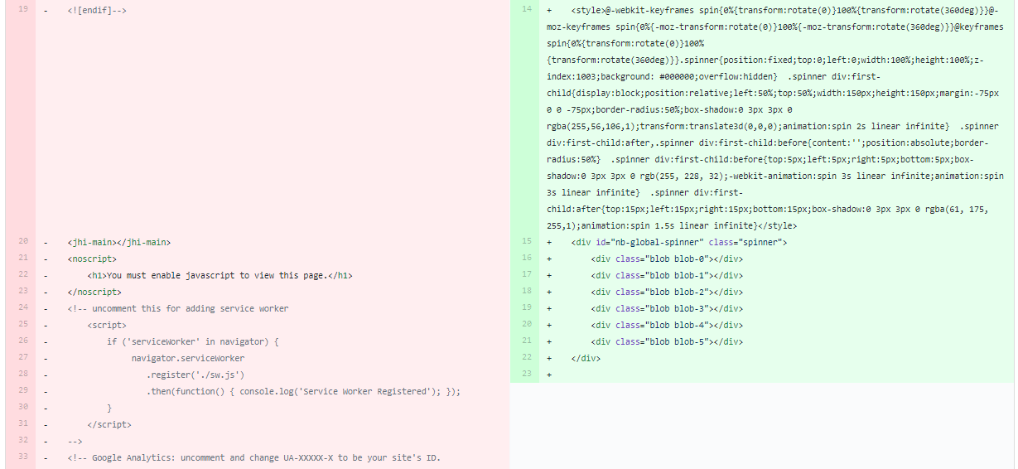

# Fix "Cannot find name 'tinymce'" error

